**Project Initialization and Planning Phase**

| Date | 27 July 2025 |
| --- | --- |
| Team ID |  |
| Project Name | Power BI Inflation Analysis: Journeying Through Global Economic Terrain |
| Maximum Marks | 3 Marks |

**Problem Statement:**

Inflation affects economies worldwide, but the impact and rates vary across countries and over time. Understanding long-term global inflation patterns can help identify economic shifts, policy effectiveness, and regional trends. However, visualizing and analyzing such extensive data is challenging without the right tools.

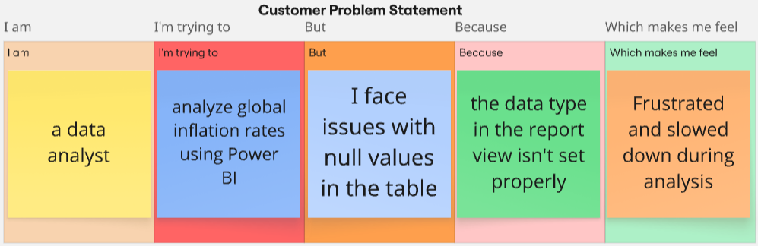

| **Problem**  **Statement (PS)** | **I am**  **(Customer)** | **I’m trying to** | **But** | **Because** | **Which makes me feel** |
| --- | --- | --- | --- | --- | --- |
| PS-1 | A beginner Power BI user | load and visualize the inflation rate data | the values are not displaying in report view | the data type in the report view isn’t set properly | confused and frustrated |
| PS-2 | an intern working on global data visualization | generate insights across countries/regions | I can't filter or analyze specific countries | I don’t know how to use filters or slicers effectively | stuck and less confident about my skills |